**ABOUT SAN JUAN COUNTY**

San Juan County waters have sustained the Coast Salish for generations and the regional economy depends on clean marine waters and wildlife. Protecting these ecosystems is vital to Puget Sound Recovery.

* 428 islands with ***408 miles of shoreline***
* ***80 miles of forage fish*** spawning beaches
* ***22 stocks of Salish Sea Chinook*** migrating through the nearshore
* ***One-third of all kelp*** in the Puget Sound
* ***Critical foraging habitat*** for the Southern Resident Orca

Derelict creosote pilings at Jackson Beach, San Juan Island.

Hunter Bay marine facility on Lopez Island.

**WHAT WE ARE DOING**

San Juan County is completing a county-wide assessment of creosote pilings. Additionally, the County will implement a strategy to incentivize swap-outs by laying out a roadmap towards permitting, design, and contracting requirements, along with determining mitigation credits associated with each site.

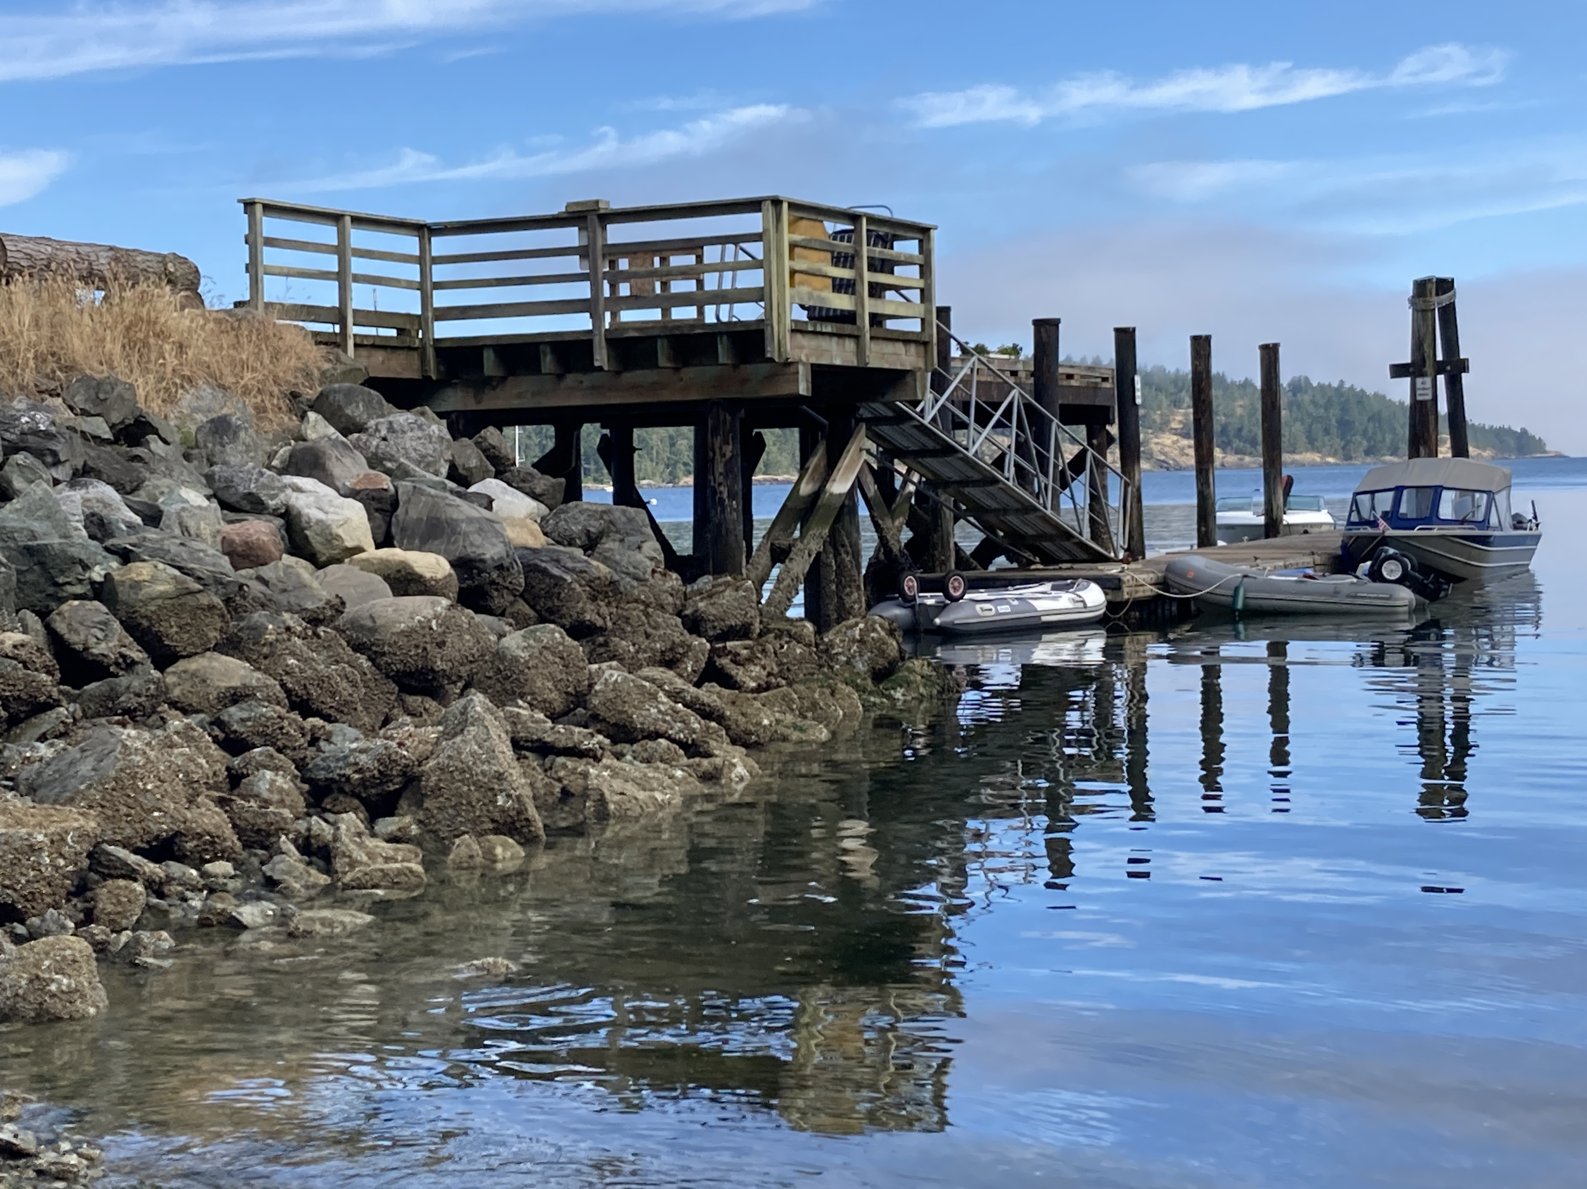

**WHAT YOU CAN DO**

To learn more about the impacts of creosote please check out the Marine Resources Committee project pages at www.sjcmrc/projects. If you would like to have the County include your pilings in our assessment, please get in touch.

**Mitigating Contamination to Nearshore Habitat from Creosote Pilings**

Creosote treated wood pilings are a significant source of contamination to nearshore environments of the Salish Sea. As creosote leaches into the marine environment, it impacts forage fish spawning habitat, valuable eelgrass beds, and other nearshore habitats and species. Creosote vapors also pose a risk to human health. Removing creosote treated material from the marine environment is a priority for San Juan County.

**WHY THIS IS IMPORTANT**

This project allows the County and landowners to plan for and potentially expedite piling removal that will:

* Eliminate a pathway for polycyclic aromatic hydrocarbons to the nearshore environment,
* Improve water quality,
* Improve conditions for eelgrass habitat,
* Reduce toxics to forage fish,
* Protect and promote habitat for rearing juvenile salmon.

**FOR MORE INFORMATION**

|  |  |
| --- | --- |
|  | **www.sanjuanco.com/1361/Marine-Resources**  Dr. Frances Robertson, San Juan County  francesr@sanjuanco.com, 360 375 52761  Project based on NTA 2018-0849 |